**LASSO-RIDGE SHRINKAGE METHODS**

1)

Here we can see that I have performed the laso shrinkage method as we can see at the 10th log value the value is 0 , Since it is a feature selection technique it is making all the values which are insignificant 0.

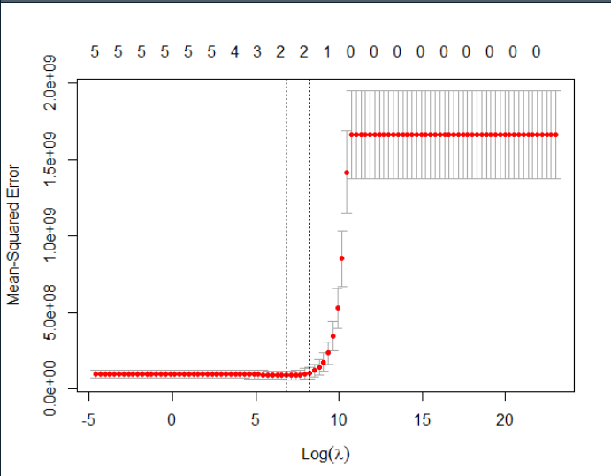

Here we can see that I have performed Ridge regression, We can clearly see that the value comes to near 0 but , but it never gets 0, since it is ridge regression.

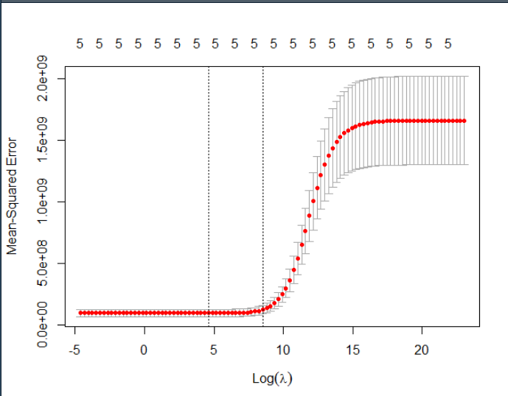

2) Here we can see that I have performed the laso shrinkage method as we can see at the 10th log value the value is 0 , Since it is a feature selection technique it is making all the values which are insignificant 0.

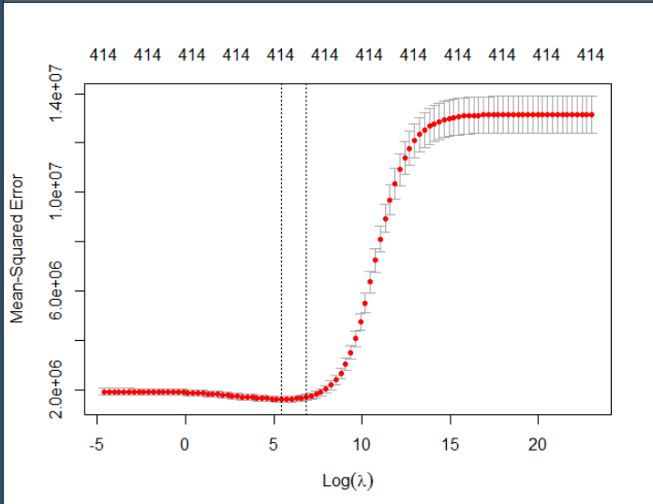

Here we can see that I have performed Ridge regression, We can clearly see that the value comes to near 0 but , but it never gets 0, since it is ridge regression.

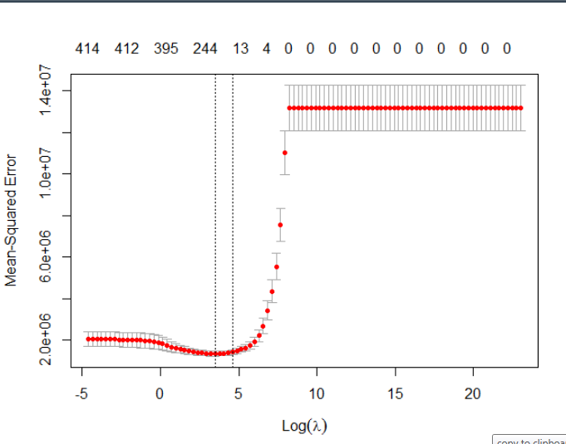

3) Here we can see that I have performed the laso shrinkage method as we can see at the 10th log value the value is 0 , Since it is a feature selection technique it is making all the values which are insignificant 0.

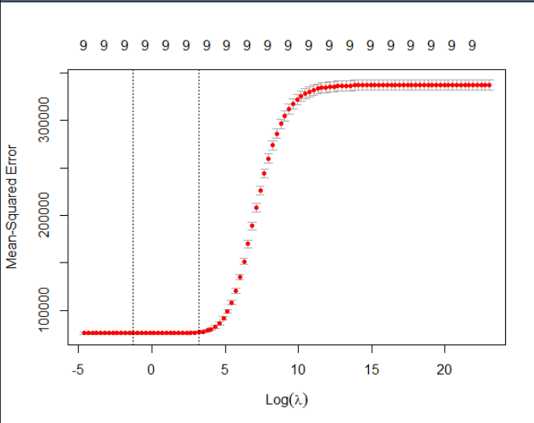

Here we can see that I have performed Ridge regression, We can clearly see that the value comes to near 0 but , but it never gets 0, since it is ridge regression.

